IONIC DESIGN
Topic Page
Adding Popover Controller 7
How to add row & column 9
Adding Parallax Effect 15

How to remove back button in page.html and displaying the menu 29
Ionic IF and else condition 30
Segment Example 32
Ionic how to add div box over image
How to add segment in ionic 33
How to add image responsive and full zoom Effect 34
Creating right Menu 35

ActionSheet Controller to display the name list of the social networking share. 40

Setting slider bullet to color
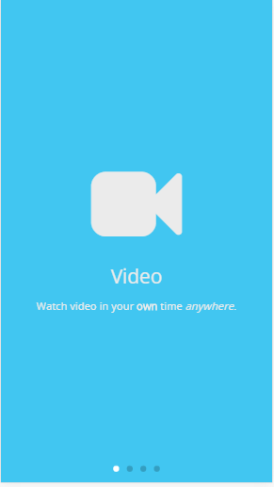
.swiper-pagination-bullet-active{
background: white;
}

<ion-slide style="background-color: #41c6f1">
<i class="fa fa-video-camera" style="font-size:120px; color:#ebebeb" aria-hidden="true"></i>
<h1 style="color:#ebebeb">Video</h1>
<p style="font-family: Open-Sans; font-size:14px; color:#ebebeb">
Watch video in your <b>own</b> time <i>anywhere</i>.
</p>
</ion-slide>

page-login {
.bg-image{
background-image: url('../assets/img/login.jpg');
background-repeat: no-repeat;
background-position: center;
background-size: cover !important;
}
.no-scroll .scroll-content{
overflow: hidden;
}
.logo{
display: block;
margin:auto;
width: 50%;
margin-top: 2vh;
}
.label {
background-color: rgba(255, 255, 255, 0.0);
}
.list{
width:50%;
position: absolute;
right: 100px;
margin:auto;
}
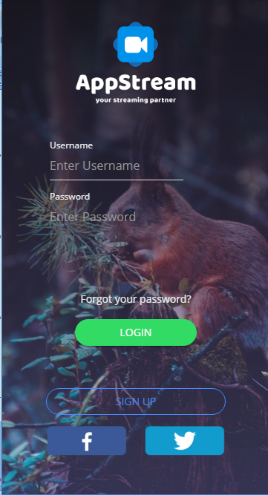

.text{
text-align: center;
margin-top:35vh;
}

.btnWidth{
width:50%;
}

.myButton{
margin-top:8vh;
width: 74%;
}

.fb-button {
position: absolute;
left: 60px;
margin-top: 1.4vh;
width: 30%;
height: auto;
}

.twitter-button {
position: absolute;
right: 60px;
margin-top: 1.4vh;
width: 30%;
height: auto;
}
}
<ion-content class="bg-image no-scroll" padding>
<img src="assets/img/logo-appstream.png" class="logo">

<div>
<ion-list class="list" inset>
<ion-item class="label">
<ion-label color="mywhite" style="font-size:12px" stacked>Username</ion-label>
<ion-input type="text" placeholder="Enter Username"></ion-input>
</ion-item>

<ion-item class="label">
<ion-label color="mywhite" style="font-size:12px" stacked>Password</ion-label>
<ion-input type="password" placeholder="Enter Password"></ion-input>
</ion-item>
</ion-list>
</div>

<p class="text" style="font-family:Open-Sans; font-size:14px; color:#ebebeb;">
Forgot your password?
</p>

<div text-center>
<button class="btnWidth" ion-button color="secondary" round>
Login
</button>

<button class="myButton" ion-button color="myWhite" round outline [navPush]="nextPage">
Sign Up
</button>
</div>

<img src="assets/img/facebook.png" class="fb-button">
<img src="assets/img/twitter.png" class="twitter-button">
</ion-content>

Ionic Video
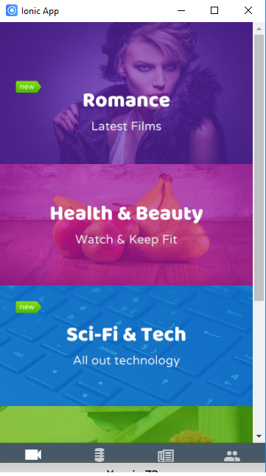
import { Component } from '@angular/core';
import { NavController } from 'ionic-angular';
import { VimeoVideo } from '../videos/vimeo';
import { YoutubeVideo } from '../videos/youtube';

@Component({
selector: 'page-video',
templateUrl: 'video.html'
})
export class VideoPage {

constructor(public navCtrl: NavController) {}

playVimeo(){
this.navCtrl.push(VimeoVideo);
}

playYoutube(){
this.navCtrl.push(YoutubeVideo);
}
}
<ion-content>
<img style="display:block" src="assets/img/video-1.jpg" (click)="playVimeo()">
<img style="display:block" src="assets/img/video-2.jpg" (click)="playYoutube()">
<img style="display:block" src="assets/img/video-3.jpg">
<img style="display:block" src="assets/img/video-4.jpg">
<img style="display:block" src="assets/img/video-5.jpg">
</ion-content>
import { Component } from '@angular/core';
import { NavController } from 'ionic-angular';

@Component({
selector: 'page-vimeo',
template: `
<ion-header>
<ion-navbar>
<ion-title>Vimeo Video</ion-title>
</ion-navbar>
</ion-header>
<ion-content>
<iframe src="https://player.vimeo.com/video/230877481" width="100%" height="100%" frameborder="0" webkitallowfullscreen mozallowfullscreen allowfullscreen>
</iframe>
</ion-content>
`
})
export class VimeoVideo {
constructor(public navCtrl: NavController) {}
}
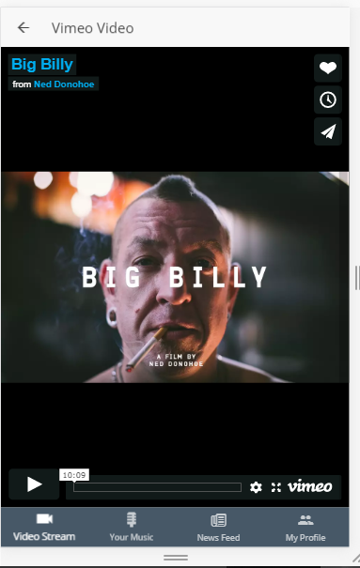
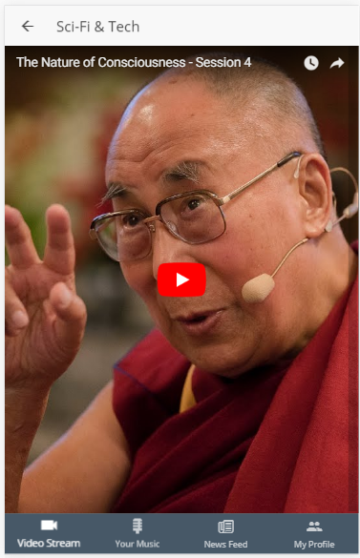
import { Component } from '@angular/core';
import { NavController } from 'ionic-angular';
import { VimeoVideo } from '../videos/vimeo';
import { YoutubeVideo } from '../videos/youtube';

@Component({
selector: 'page-video',
templateUrl: 'video.html'
})
export class VideoPage {

constructor(public navCtrl: NavController) {}

playVimeo(){
this.navCtrl.push(VimeoVideo);
}

playYoutube(){
this.navCtrl.push(YoutubeVideo);
}
}

Add the code below in config.xml
<allow-intent href="*://*.youtube.com/*" />
<allow-intent href="*://*.vimeo.com/*" />
<allow-intent href="http://*/*" />

Adding Popover Controller
In music.html add the following code
<ion-header>
<ion-navbar color="clear">
<ion-title>
<p style="font-family: Open-Sans; font-size:18px;">Playlist</p>
</ion-title>

<ion-buttons end>
<button ion-button icon-only style="color:#b7c4cb" (click)="onShowOptions($event)">
<ion-icon name="more"></ion-icon>
</button>
</ion-buttons>
</ion-navbar>
</ion-header>

In home.ts file
import { NavController,PopoverController } from 'ionic-angular';
import { MusicPop } from './music-popOver/popover';
..
export class MusicPage {

constructor(public navCtrl: NavController, public popoverCtrl: PopoverController) {
}

onShowOptions(event: MouseEvent) {
const popover = this.popoverCtrl.create(MusicPop);
popover.present({ev: event});
}
}

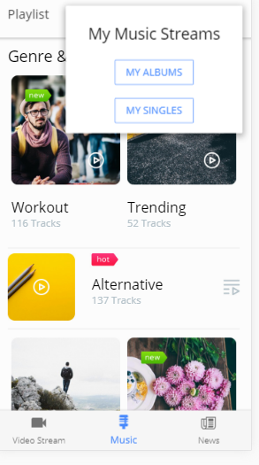

In sr/pages/music/music-popOver/ music-popOver.ts add the following code
import { Component } from '@angular/core'
import { ViewController } from 'ionic-angular';

@Component({
selector: 'page-music-pop',
template: `
<ion-grid text-center>
<ion-row>
<ion-col>
<h3>My Music Streams</h3>
</ion-col>
</ion-row>

<ion-row>
<ion-col>
<button ion-button outline>My Albums</button>
</ion-col>
</ion-row>

<ion-row>
<ion-col>
<button ion-button outline>My Singles</button>
</ion-col>
</ion-row>
</ion-grid>
`
})

export class MusicPop {

constructor(private viewCtrl: ViewController) {}

onAction(action: string) {
this.viewCtrl.dismiss({action: action});
}
}

How to add row & column
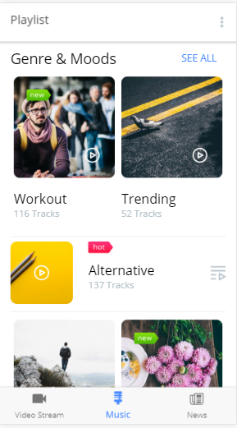
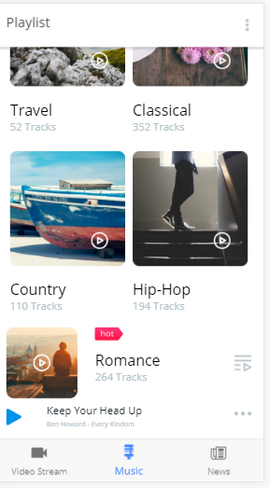
In music.html add the following code
<ion-header>
<ion-navbar color="clear">
<ion-title>
<p style="font-family: Open-Sans; font-size:18px;">Playlist</p>
</ion-title>

<ion-buttons end>
<button ion-button icon-only style="color:#b7c4cb" (click)="onShowOptions($event)">
<ion-icon name="more"></ion-icon>
</button>
</ion-buttons>
</ion-navbar>
</ion-header>

<ion-content padding>
<h3>Genre & Moods</h3>
<button class="right" ion-button clear small>
<p style="font-family:Open-Sans; font-size:15px;">
See all
</p>
</button>

<ion-row>
<ion-col>
<img src="assets/img/audio-1.jpg">
<h4 class="track">Workout</h4>
<p class="tracks">116 Tracks</p>
</ion-col>

<ion-col>
<img src="assets/img/audio-2.jpg">
<h4 class="track">Trending</h4>
<p class="tracks">52 Tracks</p>
</ion-col>
</ion-row>

<hr>
<div class="box">
<img src="assets/img/audio-3.jpg">
<div class="player">
<h4>Alternative</h4>
<p class="tracks">137 Tracks</p>
</div>
</div>

<hr>
<ion-row>
<ion-col>
<img src="assets/img/audio-4.jpg">
<h4 class="track">Travel</h4>
<p class="tracks">52 Tracks</p>
</ion-col>

<ion-col>
<img src="assets/img/audio-5.jpg">
<h4 class="track">Classical</h4>
<p class="tracks">352 Tracks</p>
</ion-col>
</ion-row>

<ion-row>
<ion-col>
<img src="assets/img/audio-6.jpg">
<h4 class="track">Country</h4>
<p class="tracks">110 Tracks</p>
</ion-col>

<ion-col>
<img src="assets/img/audio-7.jpg">
<h4 class="track">Hip-Hop</h4>
<p class="tracks">194 Tracks</p>
</ion-col>
</ion-row>

<div class="box">
<img src="assets/img/audio-8.jpg">
<div class="player">
<h4>Romance</h4>
<p class="tracks">264 Tracks</p>
</div>
</div>

<div class="box">
<img class="play" src="assets/img/play.png">
<img class="play-menu" src="assets/img/dots.png">

<div class="playing">
<p class="title">Keep Your Head Up</p>
<p class="subtitle">Ben Howard - Every Kindom</p>
</div>
</div>
</ion-content>

Checking Individual part of the music.html
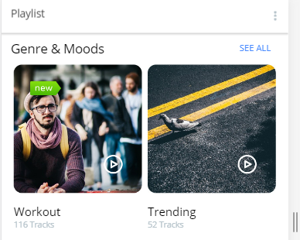
page-music {
.right{
float: right;
margin-top:-37px;
}

.tracks{
font-family: Open-Sans;
font-size: 14px;
color:#b7c4cb;
margin-top:-10px;
}

<ion-content padding>
<h3>Genre & Moods</h3>
<button class="right" ion-button clear small>
<p style="font-family:Open-Sans; font-size:15px;">
See all
</p>
</button>
<ion-row>
<ion-col>
<img src="assets/img/audio-1.jpg">
<h4 class="track">Workout</h4>
<p class="tracks">116 Tracks</p>
</ion-col>

<ion-col>
<img src="assets/img/audio-2.jpg">
<h4 class="track">Trending</h4>
<p class="tracks">52 Tracks</p>
</ion-col>
</ion-row>

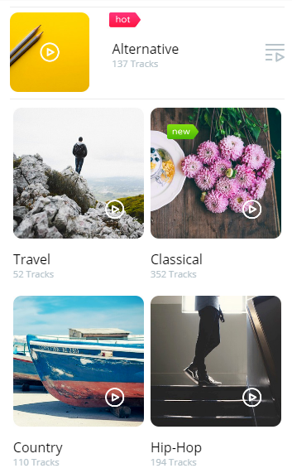
.box{
position: relative;
}

.player{
position: absolute;
left: 33vw;
top:5.5vh;
}

<hr>
<div class="box">
<img src="assets/img/audio-3.jpg">
<div class="player">
<h4>Alternative</h4>
<p class="tracks">137 Tracks</p>
</div>
</div>

<hr>
<ion-row>
<ion-col>
<img src="assets/img/audio-4.jpg">
<h4 class="track">Travel</h4>
<p class="tracks">52 Tracks</p>
</ion-col>

<ion-col>
<img src="assets/img/audio-5.jpg">
<h4 class="track">Classical</h4>
<p class="tracks">352 Tracks</p>
</ion-col>
</ion-row>

<ion-row>
<ion-col>
<img src="assets/img/audio-6.jpg">
<h4 class="track">Country</h4>
<p class="tracks">110 Tracks</p>
</ion-col>

<ion-col>
<img src="assets/img/audio-7.jpg">
<h4 class="track">Hip-Hop</h4>
<p class="tracks">194 Tracks</p>
</ion-col>
</ion-row>

<div class="box">
<img src="assets/img/audio-8.jpg">
<div class="player">
<h4>Romance</h4>
<p class="tracks">264 Tracks</p>
</div>
</div>

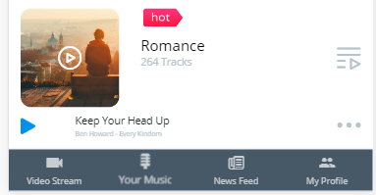
.play{
margin-top:1.5vh;
}
.play-menu{
float: right; margin-top: 2.2vh;
width: 7%;
height: auto;
}
.playing{
position: absolute; left: 15vw;
top: 2vh;
}
.title{
font-family: Open-Sans;
font-size: 14px; color:#1c252a;
margin-top: -10px;
}
.subtitle{
font-family: Open-Sans;
font-size: 9px;
color:#b7c4cb;
margin-top: -12px;
}

}

<div class="box">
<img src="assets/img/audio-8.jpg">
<div class="player">
<h4>Romance</h4>
<p class="tracks">264 Tracks</p>
</div>
</div>
<div class="box">
<img class="play" src="assets/img/play.png">
<img class="play-menu" src="assets/img/dots.png">
<div class="playing">
<p class="title">Keep Your Head Up</p>
<p class="subtitle">Ben Howard - Every Kindom</p>
</div>
</div>
</ion-content>

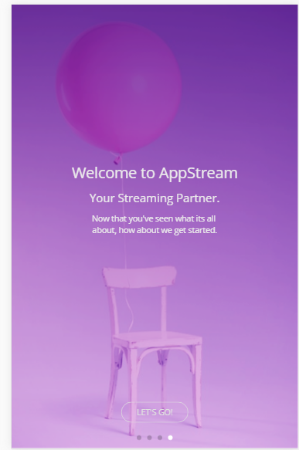
<ion-slides pager>
<ion-slide class="bg-image">
<h1 style="color:#ebebeb">Welcome to AppStream</h1>
<h4 style="color:#ebebeb">Your Streaming Partner.</h4>
<p class="padding" style="font-family: Open-Sans; font-size:14px; color:#ebebeb">
Now that you've seen what its all <br/>
about, how about we get started.
</p>
<div style="position:absolute; bottom:40px; text-align:center; z-index:1000; width:100%;">
<button ion-button round outline color="mywhite" [navPush]="nextPage">
Let's Go!
</button>
</div>
</ion-slide>
</ion-slides>
.bg-image{
background-image: url('../assets/img/bg2.png');
background-repeat: no-repeat;
background-position: center;
background-size:cover !important;;
}

Adding Parallax Effect:To create parallax first we create a components/parallax-header/parallax-header.ts To get the parallax work smoothly in IOS we need to install
Ionic add pluging https://github.com/ionic-team/cordova-plugin-wkwebview-engine.git
We also need to add the following code in config.xml
<allow-navigation href="http://ionic.local/*" />
<allow-navigation href="http://localhost:8080/*" />

In news.html we have 4 Screen shot for our application. And our page header doesn’t have border.

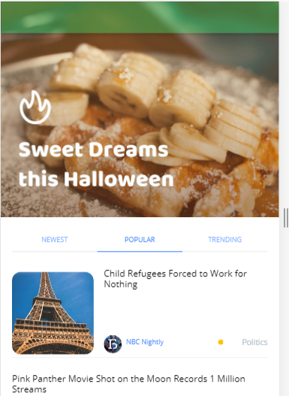
page-news {
.header-image {
background-image: url('../assets/img/newsfeed.jpg');
height: 50vh;
}
.main-content {
padding: 20px;
background-color: white;
}
.scroll-content {
// allow the scroll of content to go below the navbar
padding-top: 0 !important;
}
ion-header {
-webkit-backdrop-filter: blur(8px);
}
ion-navbar {
opacity: 0.4;
box-shadow: 0px 1px 13px 1px rgba(0, 0, 0, 0.77);
}

<ion-header no-border>
<ion-navbar color="secondary">
</ion-navbar>
</ion-header>

<ion-content fullscreen parallax-header>
<div class="header-image"></div>
<div class="main-content">
<ion-segment [(ngModel)]="stream">
<ion-segment-button value="newest">Newest</ion-segment-button>
<ion-segment-button value="popular">Popular</ion-segment-button>
<ion-segment-button value="trending">Trending</ion-segment-button>
</ion-segment>

<div class="news-box">
<img class="images" src="assets/img/paris.jpg">
<div class="detail">
<h6 class="details">Child Refugees Forced to Work for Nothing</h6>
<img class="avatar" src="assets/img/avatar02.jpg">
<p class="blog">NBC Nightly</p>
<i class="fa fa-circle dot" style="color:#ffc107" aria-hidden="true"></i>
<p class="tag">Politics</p>
</div>
</div>
<hr>

.news-box {
padding-top: 20px;
position: relative;
top: 2vh;
padding-bottom: 10px;
}
.images {
width: 32%;
}
.detail {
font-family: Open-Sans;
}
.details {
position: absolute;
left: 33vw;
top: -0.4vh;
font-family: Open-Sans;
}
.avatar {
position: absolute;
left: 33vw;
margin-top: -37px;
width: 7%;
}
.blog {
position: absolute;
font-family: Open-Sans;
font-size: 12px;
color: map-get($colors, primary) !important;
margin-top: -34px;
left: 41vw;
}
.tag {
// position: absolute;
font-family: Open-Sans;
color: #b7c4cb;
float: right;
font-size: 14px;
margin-top: -35px;
}

Inside the NewsPage
export class NewsPage {
stream : string="popular";

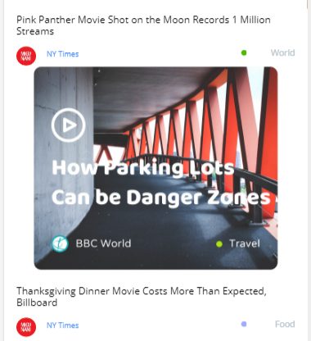

<div class="pink-panther">
<h6 style="font-family:open-sans; margin-top: 20px">
Pink Panther Movie Shot on the Moon Records 1 Million Streams</h6>
<img class="avatar02" src="assets/img/avatar.jpg">
<p class="blog02">NY Times</p>
<i class="fa fa-circle dot02" style="color:#4cb906" aria-hidden="true"></i>
<p class="tag02">World</p>
<img src="assets/img/bbc.jpg">
<h6 style="font-family:open-sans; margin-top: 20px">
Thanksgiving Dinner Movie Costs More Than Expected, Billboard
</h6>
<img class="avatar03" src="assets/img/avatar.jpg">
<p class="blog03">NY Times</p>
<i class="fa fa-circle dot03" style="color:#a0adff" aria-hidden="true"></i>
<p class="tag03">Food</p>
</div>
<hr>

.pink-panther {
position: relative;
top: 1vh;
padding-bottom: 50px;
}
.avatar02 {
float: left;
margin-top: 5px;
width: 7%;
}
.blog02 {
position: absolute;
font-family: Open-Sans;
font-size: 12px;
color: map-get($colors, primary) !important;
margin-top: 9px;
left: 10vw;
}
.tag02 {
// position: absolute;
font-family: Open-Sans;
color: #b7c4cb;
float: right;
font-size: 14px;
margin-top: 5px;
}
.avatar03 {
float: left;
margin-top: 5px;
width: 7%;
}
.blog03 {
position: absolute;
font-family: Open-Sans;
font-size: 12px;
color: map-get($colors, primary) !important;
margin-top: 9px;
left: 10vw;
}
.tag03 {
// position: absolute;
font-family: Open-Sans;
color: #b7c4cb;
float: right;
font-size: 14px;
margin-top: 5px;
}

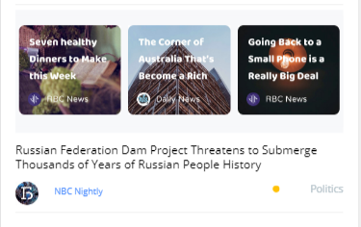
.grid {
background-color: #f7f8fa;
padding: 0;
padding-top: 8px;
padding-bottom: 8px;
}

<div class="grid">
<ion-grid>
<ion-row>
<ion-col>
<img src="assets/img/news-slide-1.jpg">
</ion-col>
<ion-col>
<img src="assets/img/news-slide-2.jpg">
</ion-col>
<ion-col>
<img src="assets/img/news-slide-3.jpg">
</ion-col>
</ion-row>
</ion-grid>
</div>

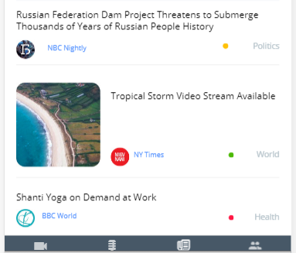

<div class="russian">
<h6 style="font-family:open-sans; margin-top: 15px">
Russian Federation Dam Project Threatens to Submerge Thousands of Years of Russian People History
</h6>
<img class="avatar03" src="assets/img/avatar02.jpg">
<p class="blog04">NBC Nightly</p>
<i class="fa fa-circle dot04" style="color:#ffc107" aria-hidden="true"></i>
<p class="tag03">Politics</p>
</div>
<hr>
<div class="beach-box">
<img class="images" src="assets/img/beach.jpg">
<div class="detail">
<h6 class="details">Tropical Storm Video Stream Available</h6>
<img class="avatar" src="assets/img/avatar.jpg">
<p class="blog">NY Times</p>
<i class="fa fa-circle dot" style="color:#4cb906" aria-hidden="true"></i>
<p class="tag">World</p>
</div>
</div>
<hr>
<div class="shanti">
<h6 style="font-family:open-sans">Shanti Yoga on Demand at Work</h6>
<img class="avatar04" src="assets/img/avatar03.jpg">
<p class="blog05">BBC World</p>
<i class="fa fa-circle dot05" style="color:#ff1744" aria-hidden="true"></i>
<p class="tag04">Health</p>
</div>
</div>
</ion-content>

.russian {
padding-bottom: 40px;
}
.blog04 {
position: absolute;
font-family: Open-Sans;
font-size: 12px;
color: map-get($colors, primary) !important;
margin-top: 9px;
left: 15vw;
}
.beach-box {
position: relative;
top: 3vh;
padding-bottom: 30px;
}
.shanti {
position: relative;
top: 1vh;
padding-bottom: 90px;
}
.avatar04 {
float: left;
margin-top: 1px;
width: 7%;
}
.blog05 {
position: absolute;
font-family: Open-Sans;
font-size: 12px;
color: map-get($colors, primary) !important;
margin-top: 4px;
left: 9vw;
}
.tag04 {
// position: absolute;
font-family: Open-Sans;
color: #b7c4cb;
float: right;
font-size: 14px;
margin-top: 5px;
}
.dot {
position: absolute;
font-size: 10px;
margin-top: -30px;
right: 16vw;
}
.dot02 {
position: absolute;
font-size: 10px;
margin-top: 10px;
right: 16vw;
}
.dot03 {
position: absolute;
font-size: 10px;
margin-top: 10px;
right: 16vw;
}
.dot04 {
position: absolute;
font-size: 10px;
margin-top: 10px;
right: 22vw;
}
.dot05 {
position: absolute;
font-size: 10px;
margin-top: 10px;
right: 16vw;
}
}

Profile page:
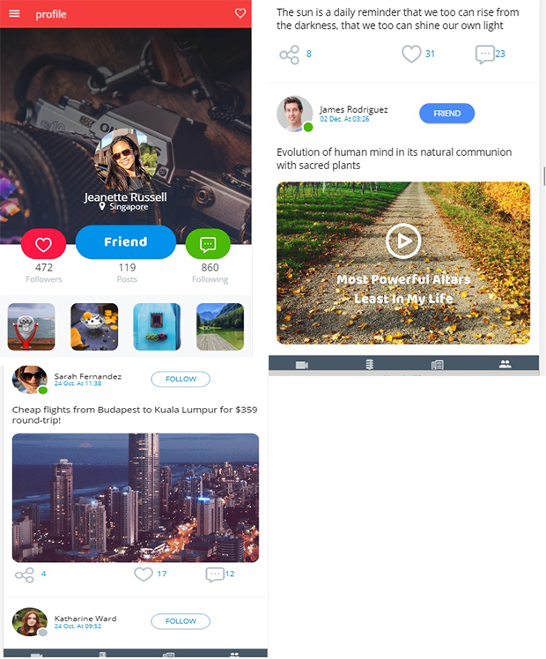
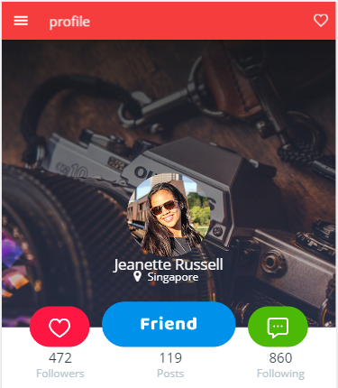

<ion-header>
<ion-navbar color="danger">
<ion-buttons left>
<button ion-button icon-only menuToggle>
<ion-icon name="menu"></ion-icon>
</button>
</ion-buttons>

<ion-title>profile</ion-title>
<ion-buttons end>
<button ion-button icon-only style="color: #ebebeb" (click)="showToast('bottom')">
<ion-icon name="heart-outline"></ion-icon>
</button>
</ion-buttons>
</ion-navbar>
</ion-header>

<ion-content fullscreen>
<div class="header-parent">
<img src="assets/img/bg2.jpg
<div class="header-social">
<img style="width:18%; margin-right:3vw" src="assets/img/love-btn.png">
<img style="width:40%;" src="assets/img/friend-btn.png">
<img style="width:18%; margin-left:3vw" src="assets/img/chat-btn.png">
</div>

<div class="profile">
<img src="assets/img/profile-pic.png">
</div>

<div class="title-name">
<h3>Jeanette Russell</h3>
</div>

<div class="profile-location">
<ion-row align-items-center>
<ion-col col-8>
<div><i class="fa fa-map-marker location-icon" aria-hidden="true"></i>
</div></ion-col>
<ion-col col-4>
<div><p class="location">Singapore</p></div>
</ion-col>
</ion-row>
</div>
</div> <! -- End of header-parent -->

<div class="counter">
<ion-row>
<ion-col>
<p class="numbers">472</p>
<p class="numbers-title">Followers</p>
</ion-col>

<ion-col>
<p class="numbers">119</p>
<p class="numbers-title">Posts</p>
</ion-col>

<ion-col>
<p class="numbers">860</p>
<p class="numbers-title">Following</p>
</ion-col>
</ion-row>
</div> <!-- End of counter -->

Profile.css
page-profile {
.header-parent {
position: relative;
text-align: center;
}
.header-social {
position: absoloute;
bottom: 0px;
text-align: center;
margin-top: -5.5vh;
}
.profile {
width: 25%;
margin: 0 auto;
margin-top: -34vh;
}
.title-name {
color: #fff;
margin-top: -3vh;
}

.location-icon {
color: #fff;
font-size: 18px;
float: right;
}

.counter {
text-align: center;
margin-top: 6.5vh;
margin-left: 1vw;
}

.numbers {
font-family: open-sans;
color: #323e46;
font-size: 20px;
}

.numbers-title {
font-family: open-sans;
color: #b7c4cb;
font-size: 16px;
margin-top: -3vh;
}

.location {
font-size: 16px;
font-family: open-sans;
color: #fff;
float: left;
}

.profile-location{
margin-top: -4.8vh;
margin-right: 36vw;
}

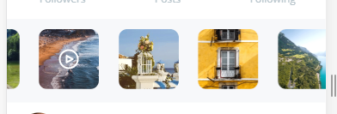

<ion-slides autoplay="2500" loop="true" slidesPerView="4" class="slides">
<ion-slide>
<img class="slide-image" src="assets/img/profile-slide1.png">
</ion-slide>
<ion-slide>
<img class="slide-image" src="assets/img/profile-slide2.png">
</ion-slide>
<ion-slide>
<img class="slide-image" src="assets/img/profile-slide3.png">
</ion-slide>
<ion-slide>
<img class="slide-image" src="assets/img/profile-slide4.png">
</ion-slide>
<ion-slide>
<img class="slide-image" src="assets/img/profile-slide5.png">
</ion-slide>
<ion-slide>
<img class="slide-image" src="assets/img/profile-slide6.png">
</ion-slide>
<ion-slide>
<img class="slide-image" src="assets/img/profile-slide7.png">
</ion-slide>
<ion-slide>
<img class="slide-image" src="assets/img/profile-slide8.png">
</ion-slide>
<ion-slide>
<img class="slide-image" src="assets/img/profile-slide9.png">
</ion-slide>
</ion-slides>

.slides {
max-height: 20%;
background-color: #f7f8fa;
}

.slide-image {
width: 75%;
}

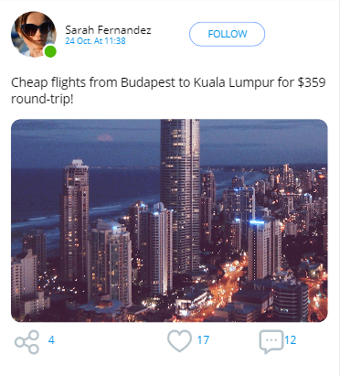

<div style="position:relative" padding>
<img style="width:15%" src="assets/img/live-profile.png">

<div style="position:absolute; margin-top:-7vh; margin-left:16vw;">
<h6>Sarah Fernandez</h6>
<p style="font-family:open-sans; font-size:12px; color:#0091ea; margin-top:-1.5vh">24 Oct. At 11:38</p>
</div>

<div style="position:absolute">
<button style="color:#0091ea; margin-top:-1.5vh; margin-left:34vh; margin-top:-14vh" ion-button round outline medium>Follow</button>
</div>

<p style="font-family:open-sans; font-size:18px">Cheap flights from Budapest to Kuala Lumpur for $359 round-trip!</p>
<img src="assets/img/tokyo.png">

</div>

<div padding style="position:relative; margin-top:-4vh">
<ion-row>
<ion-col col-4><div><img style="width:25%" src="assets/img/share.png"></div></ion-col>
<ion-col col-4><div><img style="width:25%; margin-left:14vw" src="assets/img/like.png"></div></ion-col>
<ion-col col-4><div><img style="width:25%; margin-left:10vw" src="assets/img/message.png"></div></ion-col>
</ion-row>

<div style="position:absolute" >
<ion-row>
<ion-col><div><p class="share-numbers" style="margin-left: 10vw">4</p></div></ion-col>
<ion-col><div><p class="share-numbers" style="margin-left: 40vw">17</p></div></ion-col>
<ion-col><div><p class="share-numbers" style="margin-left: 20vw">12</p></div></ion-col>
</ion-row>
</div>
</div>

<hr>

<div style="position:relative" padding>
<img style="width:15%" src="assets/img/offline-profile.png">
<div style="position:absolute; margin-top:-7vh; margin-left:16vw;">
<h6>Katharine Ward</h6>
<p style="font-family:open-sans; font-size:12px; color:#0091ea; margin-top:-1.5vh">24 Oct. At 09:52</p>
</div>
<div style="position:absolute">
<button style="color:#0091ea; margin-top:-1.5vh; margin-left:34vh; margin-top:-14vh" ion-button round outline medium>Follow</button>
</div>
<p style="font-family:open-sans; font-size:18px">The sun is a daily reminder that we too can rise from the darkness, that we too can shine our own light</p>
</div>

<div padding style="position:relative; margin-top:-4vh">
<ion-row>
<ion-col col-4><div><img style="width:25%" src="assets/img/share.png"></div></ion-col>
<ion-col col-4><div><img style="width:25%; margin-left:14vw" src="assets/img/like.png"></div></ion-col>
<ion-col col-4><div><img style="width:25%; margin-left:10vw" src="assets/img/message.png"></div></ion-col>
</ion-row>

<div style="position:absolute" >
<ion-row>
<ion-col><div><p class="share-numbers" style="margin-left: 10vw">8</p></div></ion-col>
<ion-col><div><p class="share-numbers" style="margin-left: 40vw">31</p></div></ion-col>
<ion-col><div><p class="share-numbers" style="margin-left: 20vw">23</p></div></ion-col>
</ion-row>
</div>
</div>

<hr>

<div style="position:relative" padding>
<img style="width:15%" src="assets/img/live-profile2.png">
<div style="position:absolute; margin-top:-7vh; margin-left:16vw;">
<h6>James Rodriguez</h6>
<p style="font-family:open-sans; font-size:12px; color:#0091ea; margin-top:-1.5vh">02 Dec. At 03:26</p>
</div>
<div style="position:absolute">
<button style="color:#fff; margin-top:-1.5vh; margin-left:34vh; margin-top:-14vh" ion-button round medium>Friend</button>
</div>
<p style="font-family:open-sans; font-size:18px">Evolution of human mind in its natural communion with sacred plants</p>

<img src="assets/img/video.jpg" style="width: 100%; height: 100%" (click)="nextpage()">
</div>
</ion-content>

How to remove back button in page.html and displaying the menu, when we navigate to one page to another we will have default back arrow and menu will not display by default. To get the menu we need to add following code

You need to add attribute persistent="true" to ion-menu in app.html

<ion-menu side="left" [content]="content" persistent="true"></ion-menu>

then menuToggle button will be available on all views.

For hiding back button you can try this code:

<ion-header>
<ion-navbar hideBackButton >
<ion-title>PageTitle</ion-title>
</ion-navbar>
</ion-header>

Controlling search box toggle on and off
Step 1: Add template for the search

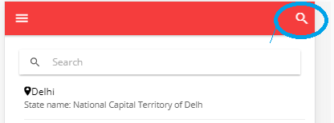
<ion-header>
<ion-navbar color="danger" hideBackButton>
<ion-buttons end>
<button ion-button icon-only (click)="showSearchBox()">
<ion-icon name="search"></ion-icon>
</button>
</ion-buttons>
</ion-navbar>
</ion-header>
<ion-content class="card-background-page">
<ion-searchbar (search)="search($event.target.value)" [ngClass]="{'show-search': showSearch }">
</ion-searchbar>

In home.ts we have to control the toogle through typescript

export class HomePage {
showSearch = false;
….// To toggle search on -off
showSearchBox() {
this.showSearch = !this.showSearch;
}
In home.scss
page-home {
ion-searchbar {
display:none;
}

.show-search {
display:block;
}
}

Ionic IF and else condition
<div *ngIf="game.screenshots; then gamescreen else noscreen"></div>

<ng-template #gamescreen>
<div class="game-image">
<img src="http:...{{ game.screenshots[0].cloudinary_id }}.jpg" class="tinted" />
</div>
</ng-template>

<ng-template #noscreen>
<div class="game-image">
<img src="assets/img/blank.png" />
</div>
</ng-template>

Ionic how to add div box over image

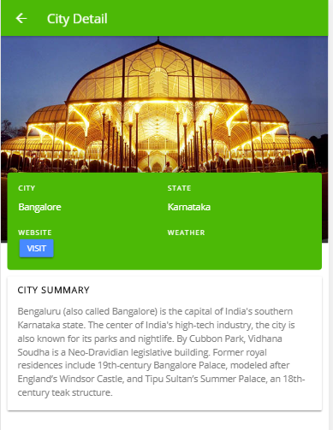
page-city-detail {
.city-image{
max-width: 100%;
margin:0;
}

.city-image::after {
display:block;
position:relative;
background-image: linear-gradient(to bottom,
rgba(0,0,0,0) 0, #000 100%);
margin-top: -150px;
height: 150px;
width:100%;
opacity: .8;
content: '';
}
<ion-content>
<div class="city-image">
<img src="assets/img/{{city.img}}.jpg" class="tinted">
</div>
<div id="popover">
<ion-grid>
<ion-row>
<ion-col col-6>
<h4>City</h4>
<p class="larger-res">{{ city.name }}</p>
</ion-col>
<ion-col col-6>
<h4>State</h4>
<p>{{ city.state }}</p>
</ion-col>
</ion-row>
<ion-row>
<ion-col col-6>
<h4>Website</h4>
<button ion-button (click)="launchSite()" small>Visit</button>
</ion-col>
<ion-col col-6>
<h4>Weather</h4>
<p></p>
</ion-col>
</ion-row>
</ion-grid>
</div>

<ion-card padding>
<h4>City Summary</h4>
<p>{{ city.summary }}</p>
</ion-card>

#popover {
width:96%;
background: #4cb906;
position:relative;
margin-top: -110px;
margin-left: auto;
margin-right: auto;
border-radius: 5px;
padding: 7px;
color:#fff;
}

h4 {
color: #fff;
text-transform: uppercase;
font-size: .8em;
letter-spacing: 1px;
margin:0;padding:0;
}

ion-card h4 {
font-weight: bold !important;
color: #0BAAB0;
margin-bottom: 15px !important;
}

ion-card p {
color: gray !important;
}

}

How to add segment in ionic
Add the following code in template
<ion-segment [(ngModel)]="cityInfo" mode="md">
<ion-segment-button value="map">Map</ion-segment-button>
<ion-segment-button value="place">Tourist Place</ion-segment-button>
<ion-segment-button value="hotel">Best Hotel</ion-segment-button>
</ion-segment>

<div [ngSwitch]="cityInfo">
<ion-list *ngSwitchCase="'map'">
<ion-item>Map</ion-item>
</ion-list>
<ion-list *ngSwitchCase="'place'">
<ion-item>Tourist place</ion-item>
</ion-list>

<ion-list *ngSwitchCase="'hotel'">
<ion-item>Hotel</ion-item>
</ion-list>
</div>

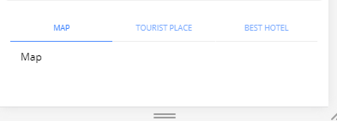

Step 2: We need to set the default value of the segment

export class CityDetailPage {
cityInfo : string="map";

Note in segment template we have mode attribute and value of the mode can be iso, android and md.

How to add image responsive and full zoom Effect
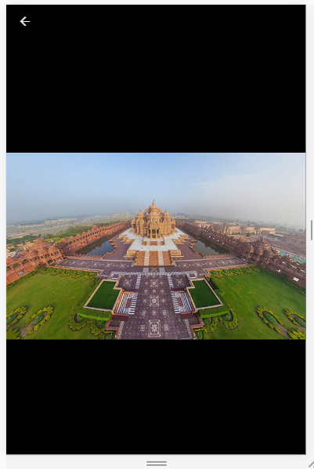
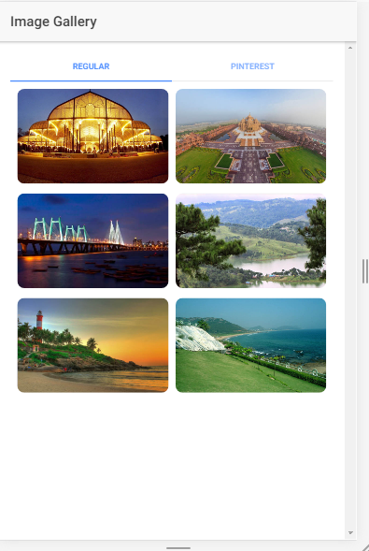

<ion-row>
<ion-col col-6 col-md-4 col-xl-3 *ngFor="let image of [1,2,3,4,5,6]">
<img class="image-container" src="assets/img/{{image}}.jpg" imageViewer/>
</ion-col>
</ion-row>

page-home {
.image-container {
background-size: cover;
border-radius:10px;
}
}

To image zoom we need to add plugin

npm install --save ionic-img-viewer

We need to add following command in app.component.ts file

import { IonicImageViewerModule } from 'ionic-img-viewer';

@NgModule({
imports: [
IonicImageViewerModule
]
})
export class AppModule {}

We need to add imageViewer attribute in image tag.

Creating right Menu

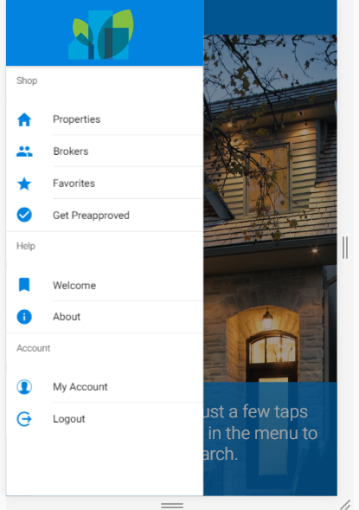
Add the following code in app.scss

.menu-logo {
height: 80px;
margin: 12px 0 0 90px;
}

ion-icon{
color:#0283df;
}

Add the following code in app.html

<ion-menu [content]="content">
<ion-header>
<ion-toolbar color="primary">
<img src="assets/img/dreamhouse-logo.svg" class="menu-logo"/>
</ion-toolbar>
</ion-header>
<ion-content>

<ion-list>
<ion-list-header>
Shop
</ion-list-header>
<button menuClose ion-item *ngFor="let menuItem of appMenuItems" (click)="openPage(menuItem)">
<ion-icon item-left [name]="menuItem.icon"></ion-icon>
{{menuItem.title}}
</button>
</ion-list>

<ion-list>
<ion-list-header>
Help
</ion-list-header>
<button menuClose ion-item *ngFor="let menuItem of helpMenuItems" (click)="openPage(menuItem)">
<ion-icon item-left [name]="menuItem.icon"></ion-icon>
{{menuItem.title}}
</button>
</ion-list>

<ion-list>
<ion-list-header>
Account
</ion-list-header>
<button menuClose ion-item *ngFor="let menuItem of accountMenuItems" (click)="openPage(menuItem)">
<ion-icon item-left [name]="menuItem.icon"></ion-icon>
{{menuItem.title}}
</button>
</ion-list>

</ion-content>
</ion-menu>

<ion-nav [root]="rootPage" #content swipeBackEnabled="false"></ion-nav>

In welcome page add the following code
<ion-header>
<ion-navbar>
<button ion-button menuToggle>
<ion-icon name="menu"></ion-icon>
</button>
<ion-title>Welcome</ion-title>
</ion-navbar>
</ion-header>

<ion-content no-bounce>
...

</ion-content>

Creating Search box, property list and segment at the bottom

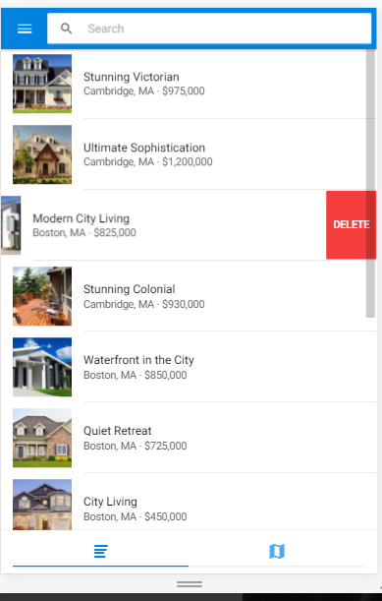
.searchbar-input {
box-shadow: none !important;
}

ion-footer {
padding: 8px 16px !important;
}

<ion-header>
<ion-navbar>
<button ion-button menuToggle>
</button>
<ion-searchbar [(ngModel)]="searchKey" (ionInput)="onInput($event)"
(ionCancel)="onCancel($event)"></ion-searchbar>
</ion-navbar>
</ion-header>

<ion-content class="property-list">

<ion-list *ngIf="viewMode==='list'">
<ion-item-sliding *ngFor="let property of properties">
<button ion-item (click)="openPropertyDetail(property)">
<ion-thumbnail item-left>
<img src="{{property.thumbnail}}"/>
</ion-thumbnail>
<h2>{{property.title}}</h2>
<p>{{property.city}}, {{property.state}} ∙ {{ property.price }}</p>
</button>
<ion-item-options>
<button ion-button (click)="deleteItem(property)" color="danger">Delete</button>
</ion-item-options>
</ion-item-sliding>

</ion-list>
<!—Segment for displaying map -- >
<div *ngIf="viewMode==='map'" style="width:100%;height:100%;" id="map"></div>
</ion-content>

<ion-footer padding>
<ion-segment [(ngModel)]="viewMode">
<ion-segment-button value="list">
<ion-icon name="list"></ion-icon>
</ion-segment-button>
<ion-segment-button value="map" (ionSelect)="showMap()">
<ion-icon name="map"></ion-icon>
</ion-segment-button>
</ion-segment>
</ion-footer>

Note in type script: viewMode: string = "list";

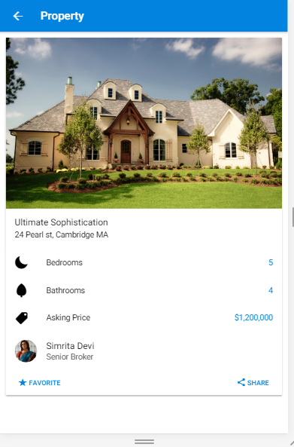

ion-note {
color: color($colors, primary) !important;
font-size: 1.4rem !important;
}

<ion-header>
<ion-navbar>
<ion-title>Property</ion-title>
</ion-navbar>
</ion-header>

<ion-content>
<ion-card *ngIf="property.id">
<img src="{{property.picture}}"/>
<ion-card-content>
<h2 class="card-title">{{property.title}}</h2>
<p>{{property.address}}, {{property.city}} {{property.state}}</p>
</ion-card-content>
<ion-list>
<ion-item>
<ion-icon item-left name="moon"></ion-icon>
<h3>Bedrooms</h3>
<ion-note item-right>{{property.bedrooms}}</ion-note>
</ion-item>
<ion-item>
<ion-icon item-left name="leaf"></ion-icon>
<h3>Bathrooms</h3>
<ion-note item-right>{{property.bathrooms}}</ion-note>
</ion-item>
<ion-item>
<ion-icon item-left name="pricetag"></ion-icon>
<h3>Asking Price</h3>
<ion-note item-right>{{property.price}}</ion-note>
</ion-item>
<button ion-item (click)="openBrokerDetail(property.broker)">
<ion-avatar item-left>
<img src="{{property.broker.picture}}"/>
</ion-avatar>
<h2>{{property.broker.name}}</h2>
<p>{{property.broker.title}}</p>
</button>
</ion-list>

<ion-item>
<button ion-button icon-left (click)="favorite(property)" clear item-left>
<ion-icon name="star"></ion-icon>
Favorite
</button>
<button ion-button icon-left (click)="share(property)" clear item-right>
<ion-icon name="share"></ion-icon>
Share
</button>
</ion-item>

</ion-card>
</ion-content>

Note : ActionSheet Controller
On Clicking on share icon will display the name list of the social networking share.

An Action Sheet is a dialog that lets the user choose from a set of options. It appears on top of the app's content, and must be manually dismissed by the user before they can resume interaction with the app. Dangerous (destructive) options are made obvious in ios mode. There are easy ways to cancel out of the action sheet, such as tapping the backdrop or hitting the escape key on desktop.

We will use the ActionSheetController we have to an import and injected into the constructor as actionSheetCtrl to create a new Action Sheet. In the process of calling create we will pass in an options object that will have a title property that will have a value of a string and a buttons property. The buttons property will have a value of an array of buttons.

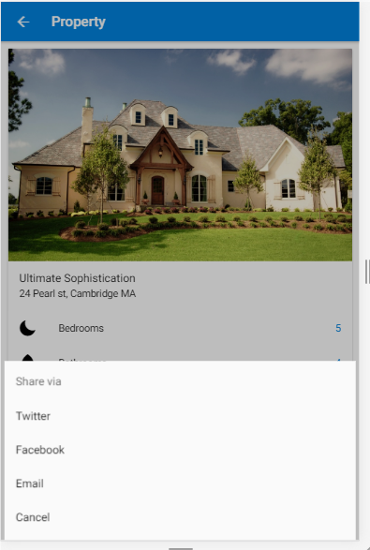

Add the following code in typescript

import {Component} from '@angular/core';
import {ActionSheetController, ActionSheet } from 'ionic-angular';

export class PropertyDetailPage {

constructor(public actionSheetCtrl: ActionSheetController) {
);
}
}

share(property) {
let actionSheet: ActionSheet = this.actionSheetCtrl.create({
title: 'Share via',
buttons: [
{
text: 'Twitter',
handler: () => console.log('share via twitter')
},
{
text: 'Facebook',
handler: () => console.log('share via facebook')
},
{
text: 'Email',
handler: () => console.log('share via email')
},
{
text: 'Cancel',
role: 'cancel',
handler: () => console.log('cancel share')
}
]
});

actionSheet.present();
}

How to add Toast Controller
A Toast is a subtle notification commonly used in modern applications. It can be used to provide feedback about an operation or to display a system message. The toast appears on top of the app’s content and can be dismissed by the app to resume user interaction with the app. Example

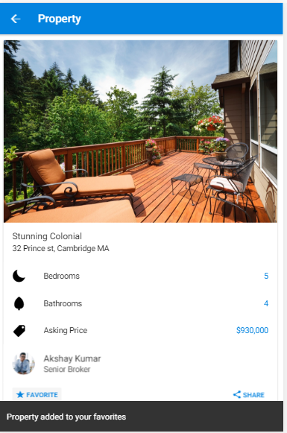
On Clicking on Favorite at the bottom of the page will display the toast message.

<button ion-button icon-left (click) ="favorite(property)"
clear item-left>
<ion-icon name="star"></ion-icon>
Favorite
</button>

import {Component} from '@angular/core';
import { ToastController} from 'ionic-angular';

@Component({
selector: 'page-property-detail',
templateUrl: 'property-detail.html'
})
export class PropertyDetailPage {

property: any;

constructor(.. public toastCtrl: ToastController) {}

favorite(property) {
this.propertyService.favorite(property)
.then(property => {
let toast = this.toastCtrl.create({
message: 'Property added to your favorites',
cssClass: 'mytoast',
duration: 1000
});
toast.present(toast);
});
}

Creating avatar

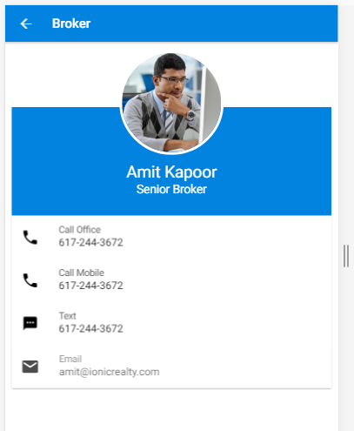

<ion-header>
….
</ion-header>

<ion-content class="broker">
<ion-card>
<ion-card-content>
<img src="{{broker.picture}}"/>
<h2>{{broker.name}}</h2>
<h3>{{broker.title}}</h3>
</ion-card-content>

<ion-list>
<a href="tel:{{broker.Phone__c}}" ion-item>
<ion-icon name="call" item-left></ion-icon>
<p>Call Office</p>
<h2>{{broker.phone}}</h2>
</a>
<a href="tel:{{broker.phone}}" ion-item>
<ion-icon name="call" item-left></ion-icon>
<p>Call Mobile</p>
<h2>{{broker.mobilePhone}}</h2>
</a>
<a href="tel:{{broker.phone}}" ion-item>
<ion-icon name="text" item-left></ion-icon>
<p>Text</p>
<h2>{{broker.mobilePhone}}</h2>
</a>
<a href="mailto:{{broker.email}}" ion-item>
<ion-icon name="mail" item-left></ion-icon>
<p>Email</p>
<h2>{{broker.email}}</h2>
</a>
</ion-list>
</ion-card>
</ion-content>

.broker {

ion-card {
margin-top: 100px;
overflow: visible;

ion-card-content {
background-color: map-get($colors, primary);
color: #FFFFFF;
text-align: center;
padding-bottom: 28px;

img {
height: 160px;
width: 160px;
border-radius: 50%;
margin-top: -100px;
border: solid 4px #FFFFFF;
display: inline;
}

h2 {
font-size: 2.5rem;
margin-top: .5rem;
color: white;
}

h3 {
font-size: 1.8rem;
color: white;
}
}
}
}

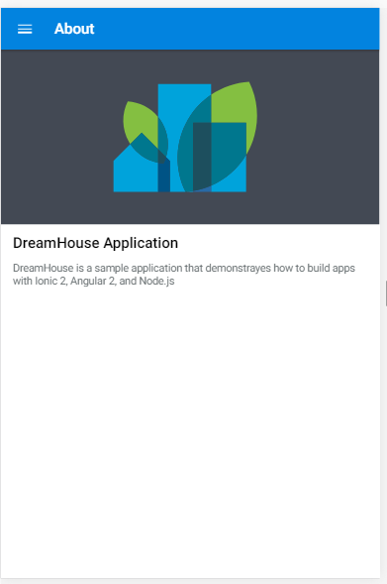
<ion-header>
<ion-navbar>
<button ion-button menuToggle>
<ion-icon name="menu"></ion-icon>
</button>
<ion-title>About</ion-title>
</ion-navbar>
</ion-header>

<ion-content>
<div class="about-header">
<img src="assets/img/dreamhouse-logo.svg">
</div>

<div padding class="about-info">
<h4>DreamHouse Application</h4>

<p>
DreamHouse is a sample application that demonstrayes how to build apps with Ionic 2, Angular 2, and Node.js
</p>
</div>
</ion-content>

.about-header {
background-color: #434954;
padding: 16px;
width: 100%;
min-height: 150px;
text-align: center;
}

.about-header img {
max-width: 200px;
min-height: 115px;
margin-left: -15px;
padding: 25px 0 20px 0;
}

.about-info p {
color: #697072;
text-align: left;
}

.about-info ion-icon {
color: color($colors, primary);
width: 20px;
}

.md,
.wp {
.about-info [text-right] {
margin-right: 0;
}
}

.ios .about-info {
text-align: center;
}

.ios .about-info ion-icon {
width: auto;
margin-right: 10px;
}

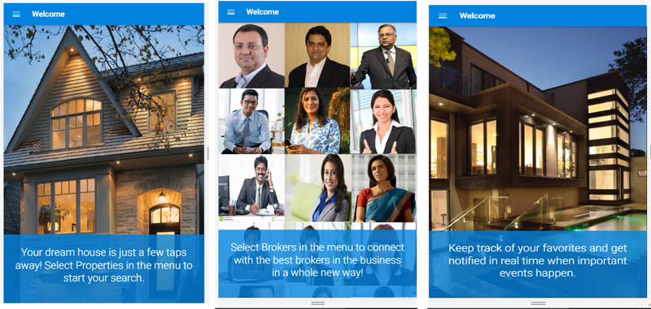

Ionic Slider For Dream house apps

<ion-header>
<ion-navbar>
<button ion-button menuToggle>
<ion-icon name="menu"></ion-icon>
</button>
<ion-title>Welcome</ion-title>
</ion-navbar>
</ion-header>

<ion-content no-bounce>
<ion-slides>
<ion-slide style="background-image: url('assets/img/slide_properties.jpg')">
<p>Your dream house is just a few taps away! Select Properties in the menu to start your search.</p>
</ion-slide>

<ion-slide style="background-image: url('assets/img/slide_brokers.jpg')">
<p>Select Brokers in the menu to connect with the best brokers in the business in a whole new way!</p>
</ion-slide>

<ion-slide style="background-image: url('assets/img/slide_favorites.jpg')">
<p>Keep track of your favorites and get notified in real time when important events happen.</p>
</ion-slide>
</ion-slides>
</ion-content>

page-welcome {
font-weight: 300;

ion-icon{
color:#fff;
}

ion-slide {
position: relative;
background-size: cover;

p {
position: absolute;
bottom: 0;
left: 0;
right: 0;
background-color: rgba(2,131,223, .8);
color: #FFFFFF;
padding: 28px 28px 48px 28px;
font-size: 2.7rem;
margin-bottom: 0;
}

img {
width: 50px;
height: 50px;
margin-top: -150px
}
}
.swiper-pagination-bullet {
background: white;
}
}

Broker List
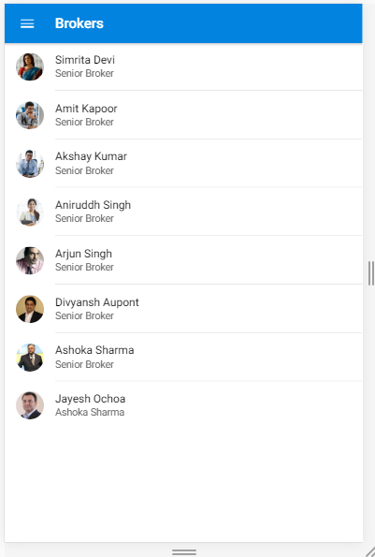

</ion-header>

<ion-content>
<ion-list>
<button ion-item *ngFor="let broker of brokers" (click)="openBrokerDetail(broker)">
<ion-avatar item-left>
<img src="{{broker.picture}}"/>
</ion-avatar>
<h2>{{broker.name}}</h2>
<p>{{broker.title}}</p>
</button>

</ion-list>
</ion-content>

<ion-content></ion-content>

<ion-footer>
<ion-toolbar>
<ion-title>Footer</ion-title>
</ion-toolbar>
</ion-footer>

Ionic Login Page:

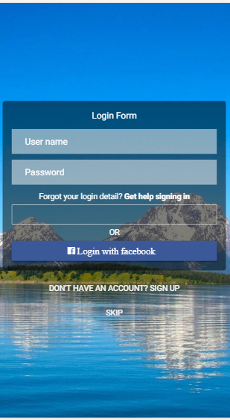

<ion-content class="background">
<ion-card>
<ion-card-header>Login Form</ion-card-header>
<ion-card-content>
<ion-list no-line>
<ion-item>
<ion-input type="text" placeholder="User name"></ion-input>
</ion-item>
<ion-item>
<ion-input type="password" placeholder="Password"></ion-input>
</ion-item>

<a>Forgot your login detail? <b>Get help signing in</b></a>
<button ion-button block outline color="light"></button>
<p>OR</p>
<button ion-button block color="facebook">
<ion-icon name="logo-facebook"> Login with facebook</ion-icon>
</button>

</ion-list>
</ion-card-content>
</ion-card>
<button ion-button clear full color="light">Don't have an account? Sign up</button>
<button ion-button clear full color="light" (click)="nextPage()">Skip</button>
</ion-content>

page-login {
.background {
background-image: url('../assets/img/bg.jpg');
}

.scroll-content {
align-content: center;
display: flex;
flex-direction: column;
justify-content: center;
text-align: center;
}

ion-card.card {
box-shadow: none;
background: rgba(0, 0, 0, 0.5);
border-radius: 5px;
}

a, p,
ion-card-header.card-header {
color: #fff!important;
}

.list > .item-block:first-child {
border: medium none;
}

.item {
margin-bottom: 10px;
background: rgba(255, 255, 255, 0.5);
border: medium none;

.text-input, {
color: #fff;
}

input::-moz-placeholder {
color: #fff!important;
}

input:-moz-placeholder {
color: #fff!important;
}

*::-webkit-input-placeholder {
color: #fff!important;
}

*:-ms-input-placeholder {
color: #fff!important;
}

*:-moz-placeholder {
color: #fff!important;
}
}

.icon {
padding-right: 10px;
}

.bottom {
position: absolute;
bottom: 0;
}
}

